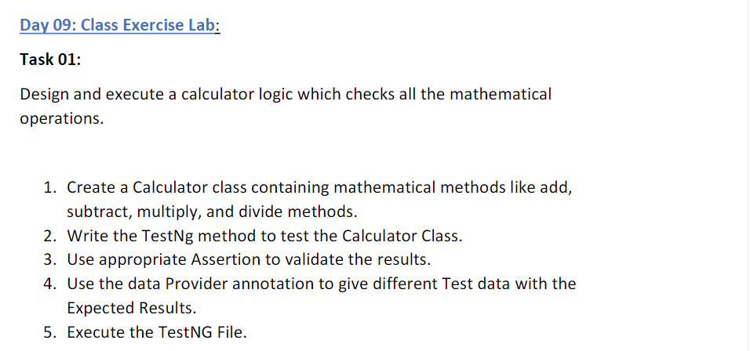

**CODE:**

package uth.Day9;

import org.testng.annotations.Test;

import org.testng.annotations.DataProvider;

public class CE1 {

@Test(dataProvider = "dp",priority=1)

public void add(Integer n1, Integer n2) {

System.out.println("Add "+(n1+n2));

}

@Test(dataProvider = "dp",priority=2)

public void sub(Integer n1, Integer n2) {

System.out.println("Sub "+(n1-n2));

}

@Test(dataProvider = "dp",priority=3)

public void mul(Integer n1, Integer n2) {

System.out.println("Mul "+n1*n2);

}

@Test(dataProvider = "dp",priority=4)

public void div(Integer n1, Integer n2) {

System.out.println("Div "+n1/n2);

}

@DataProvider

public Object[][] dp() {

return new Object[][] {

new Object[] { 20, -10 },

new Object[] { 40, -30 },

};

}

}

**OUTPUT:**

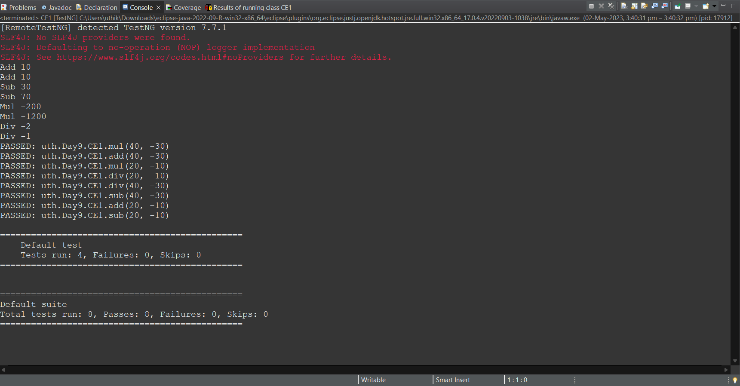

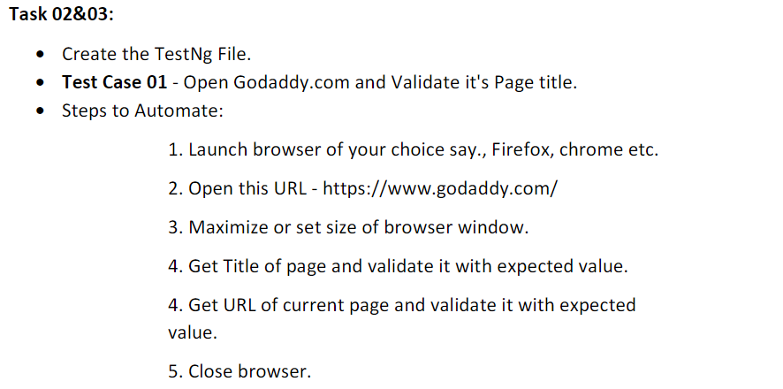

**CODE:**

package uth.Day9;

import org.openqa.selenium.By;

import org.openqa.selenium.WebDriver;

import org.openqa.selenium.chrome.ChromeDriver;

import org.openqa.selenium.chrome.ChromeOptions;

import org.testng.Assert;

import org.testng.annotations.AfterMethod;

import org.testng.annotations.BeforeMethod;

import org.testng.annotations.Test;

import io.github.bonigarcia.wdm.WebDriverManager;

public class CE2 {

WebDriver driver;

*@Test*(groups="SmokeTest")

public void validate() {

ChromeOptions co = new ChromeOptions();

co.addArguments("--remote-allows-origins=*");

WebDriverManager.*chromedriver*().setup();

driver = new ChromeDriver(co);

driver.get("https://www.godaddy.com/");

driver.manage().window().maximize();

String actualTitle = driver.getTitle();

String expectedTitle = "Domain Names, Websites, Hosting & Online Marketing Tools - GoDaddy IN";

Assert.*assertEquals*(actualTitle, expectedTitle);

String actualUrl = driver.getCurrentUrl();

String expectedUrl = "https://www.godaddy.com/en-in";

Assert.*assertEquals*(actualUrl, expectedUrl);

}

*@Test*(groups="RegressionTestCase")

public void search() throws InterruptedException

{

ChromeOptions co = new ChromeOptions();

co.addArguments("--remote-allows-origins=*");

WebDriverManager.*chromedriver*().setup();

driver = new ChromeDriver(co);

driver.get("https://www.godaddy.com/");

driver.manage().window().maximize();

Thread.*sleep*(3000);

driver.findElement(By.*xpath*("/html/body/header/div/section/div/div[1]/nav/div[2]/div[1]/ul/li[1]/button")).click();

Thread.*sleep*(3000);

driver.findElement(By.*linkText*("Domain Name Search")).click();;

}

*@Test*(groups="RegressionTestCase")

public void case3() throws InterruptedException

{

ChromeOptions co = new ChromeOptions();

co.addArguments("--remote-allows-origins=*");

WebDriverManager.*chromedriver*().setup();

driver = new ChromeDriver(co);

driver.get("https://www.godaddy.com/");

driver.manage().window().maximize();

Thread.*sleep*(3000);

driver.findElement(By.*xpath*("/html/body/header/div/section/div/div[1]/nav/div[2]/div[1]/ul/li[1]/button")).click();

Thread.*sleep*(3000);

driver.findElement(By.*linkText*("Domain Name Search")).click();

Thread.*sleep*(3000);

String title = driver.getTitle();

System.***out***.println(title);

Assert.*assertEquals*(title, "GoDaddy Domain Search - Buy and Register Available Domain Names");

Thread.*sleep*(5000);

boolean isSearchBoxPresent = driver.findElement(By.*name*("searchText")).isDisplayed();

Assert.*assertEquals*(isSearchBoxPresent, true);

}

*@BeforeMethod*

public void beforeMethod() throws InterruptedException {

}

*@AfterMethod*

public void afterMethod() {

// driver.close();

}

}

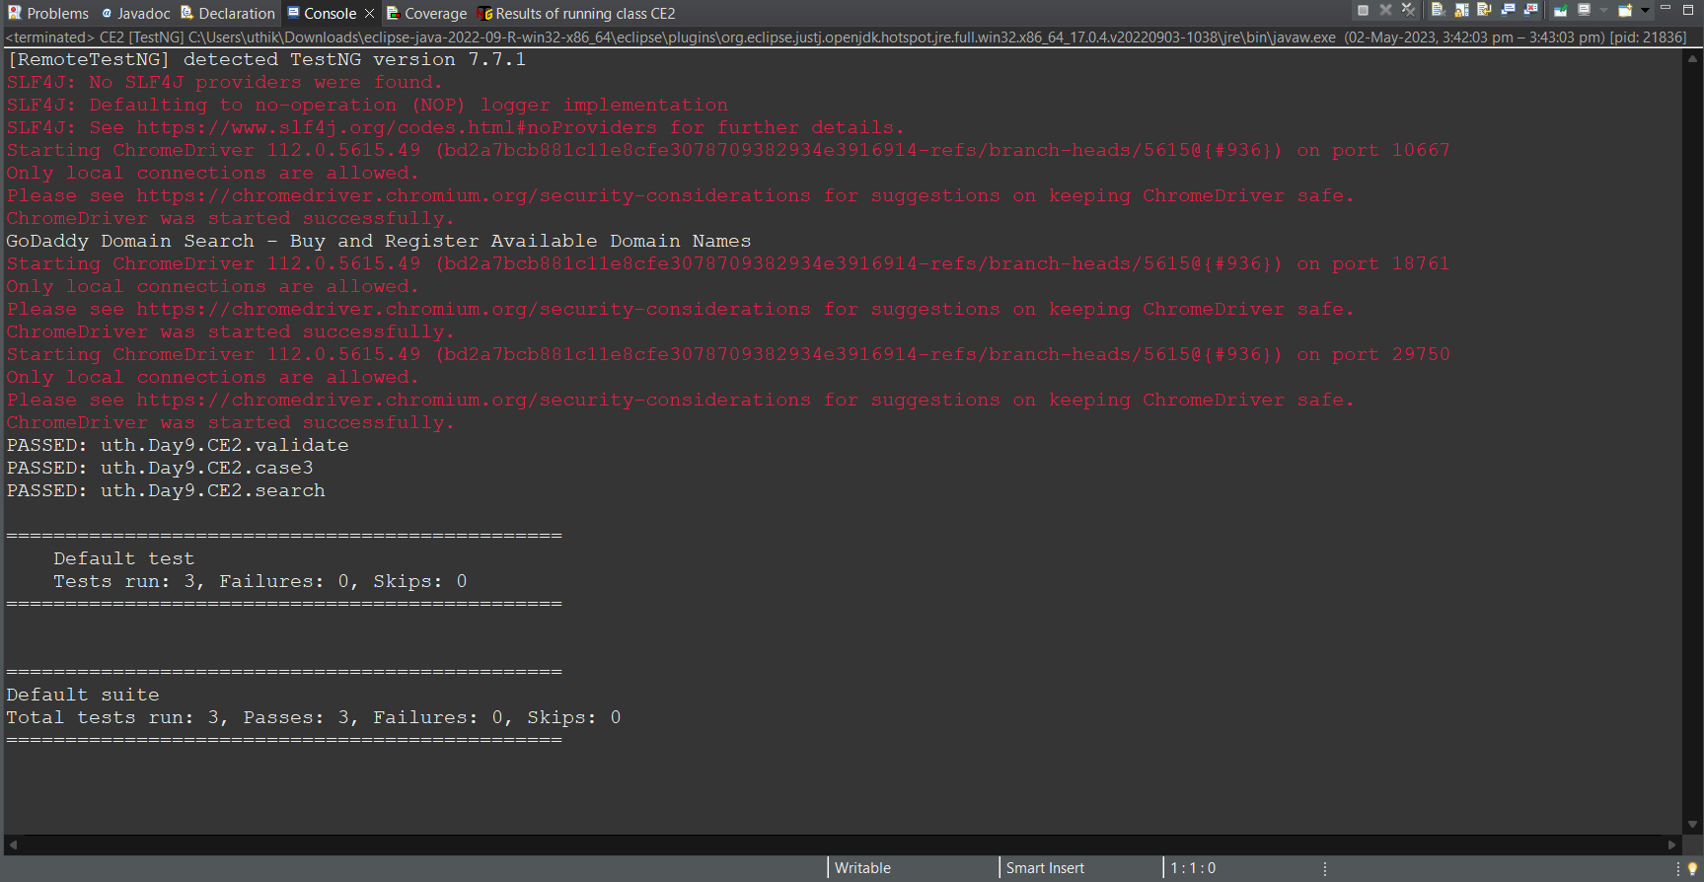

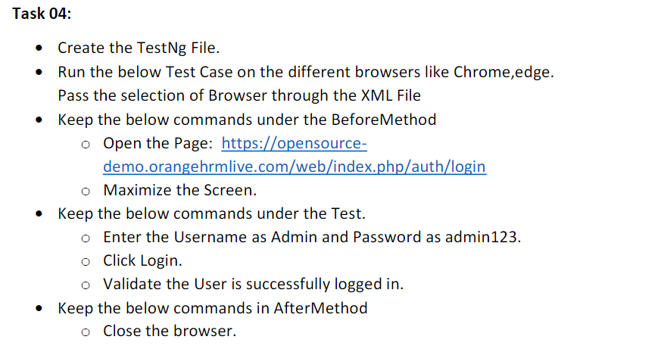

**CODE:**

package uth.Day9;

import org.openqa.selenium.By;

import org.openqa.selenium.WebDriver;

import org.openqa.selenium.WebElement;

import org.openqa.selenium.chrome.ChromeDriver;

import org.openqa.selenium.chrome.ChromeOptions;

import org.openqa.selenium.edge.EdgeDriver;

import org.openqa.selenium.edge.EdgeOptions;

import org.testng.Assert;

import org.testng.annotations.AfterMethod;

import org.testng.annotations.BeforeMethod;

import org.testng.annotations.Parameters;

import org.testng.annotations.Test;

import io.github.bonigarcia.wdm.WebDriverManager;

public class CE4 {

WebDriver driver;

*@Test*

public void checklogin() throws InterruptedException {

WebElement username = driver.findElement(By.*name*("username"));

username.sendKeys("Admin");

WebElement passwordInput = driver.findElement(By.*name*("password"));

passwordInput.sendKeys("admin123");

WebElement loginButton = driver.findElement(By.*xpath*("//*[@id=\"app\"]/div[1]/div/div[1]/div/div[2]/div[2]/form/div[3]/button"));

loginButton.click();

Thread.*sleep*(4000);

WebElement msg = driver.findElement(By.*xpath*("//*[@id=\"app\"]/div[1]/div[1]/header/div[1]/div[1]/span/h6"));

String messageText = msg.getText();

Assert.*assertEquals*(messageText,"Dashboard");

}

*@Parameters*({"browser"})

*@BeforeMethod*()

public void beforeMethod(String browser1) throws InterruptedException {

if(browser1.equals("chrome")) {

ChromeOptions co = new ChromeOptions();

co.addArguments("--remote-allow-origin=*");

WebDriverManager.*chromedriver*().setup();

driver = new ChromeDriver(co);

driver.get("https://opensource-demo.orangehrmlive.com/web/index.php/auth/login");

driver.manage().window().maximize();

Thread.*sleep*(4000);

}

else if(browser1.equals("Edge")) {

EdgeOptions co = new EdgeOptions();

co.addArguments("--remote-allow-origin=*");

WebDriverManager.*chromedriver*().setup();

driver = new EdgeDriver(co);

driver.get("https://opensource-demo.orangehrmlive.com/web/index.php/auth/login");

driver.manage().window().maximize();

Thread.*sleep*(4000);

}

}

*@AfterMethod*

public void afterMethod() {

driver.close();

}

}

**CE4.xml:**

<?xml version="1.0" encoding="UTF-8"?>

<!DOCTYPE suite SYSTEM "https://testng.org/testng-1.0.dtd">

<suite parallel="methods" name="Suite">

<test name="Test">

<parameter name="browser" value="Edge"/>

<classes>

<class name="uth.Day9.CE4"/>

</classes>

</test> <!-- Test -->

</suite> <!-- Suite -->

**OUTPUT:**

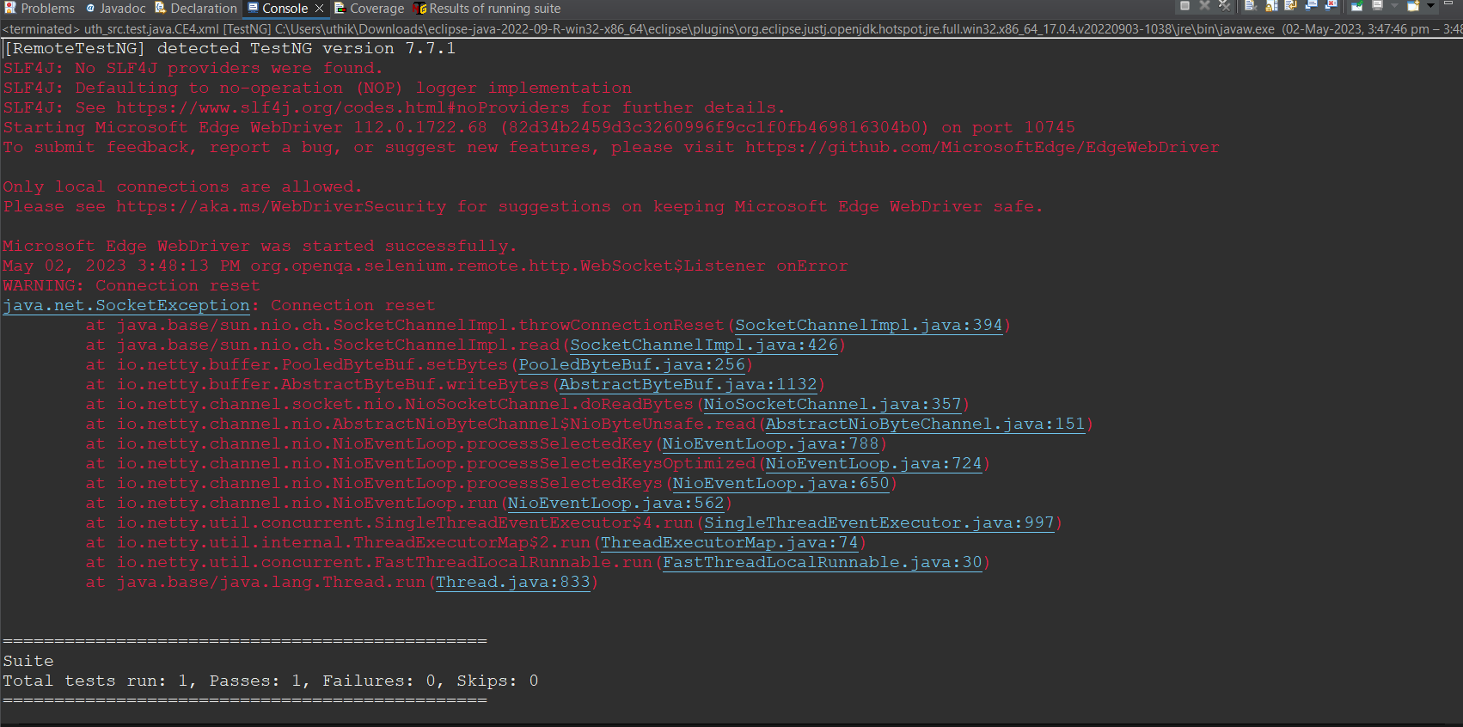

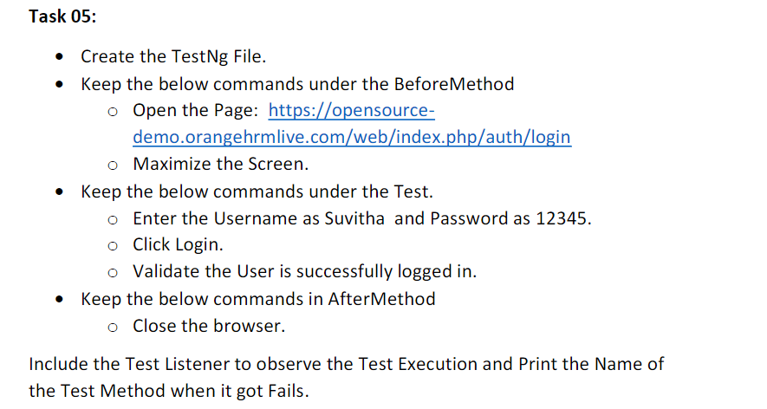

**CODE:**

package uth.Day9;

import org.openqa.selenium.By;

import org.openqa.selenium.WebDriver;

import org.openqa.selenium.WebElement;

import org.openqa.selenium.chrome.ChromeDriver;

import org.openqa.selenium.chrome.ChromeOptions;

import org.testng.Assert;

import org.testng.annotations.AfterMethod;

import org.testng.annotations.BeforeMethod;

import org.testng.annotations.Test;

import io.github.bonigarcia.wdm.WebDriverManager;

public class CE5 {

WebDriver driver;

@Test

public void checklogin() throws InterruptedException {

WebElement username = driver.findElement(By.name("username"));

username.sendKeys("Suvitha");

WebElement passwordInput = driver.findElement(By.name("password"));

passwordInput.sendKeys("12345");

WebElement loginButton = driver.findElement(By.xpath("//*[@id=\"app\"]/div[1]/div/div[1]/div/div[2]/div[2]/form/div[3]/button"));

loginButton.click();

Thread.sleep(4000);

WebElement msg = driver.findElement(By.xpath("//*[@id=\"app\"]/div[1]/div[1]/header/div[1]/div[1]/span/h6"));

String messageText = msg.getText();

Assert.assertEquals(messageText,"Dashboard");

}

@BeforeMethod

public void beforeMethod() throws InterruptedException {

ChromeOptions co = new ChromeOptions();

co.addArguments("--remote-allow-origin=*");

WebDriverManager.chromedriver().setup();

driver = new ChromeDriver(co);

driver.get("https://opensource-demo.orangehrmlive.com/web/index.php/auth/login");

driver.manage().window().maximize();

Thread.sleep(4000);

}

@AfterMethod

public void afterMethod() {

driver.close();

}

}

**Listener_1.java:**

package uth.Day9;

import org.testng.ITestContext;

import org.testng.ITestListener;

import org.testng.ITestResult;

public class Listener_1 implements ITestListener{

public void onTestStart(ITestResult result) {

// TODO Auto-generated method stub

System.*out*.println("Test onTestStart "+result.getName());

}

public void onTestSuccess(ITestResult result) {

// TODO Auto-generated method stub

System.*out*.println("Test onTestSuccess "+result.getName());

}

public void onTestFailure(ITestResult result) {

// TODO Auto-generated method stub

System.*out*.println("Test onTestFailure "+result.getName());

}

public void onTestSkipped(ITestResult result) {

// TODO Auto-generated method stub

System.*out*.println("Test onTestSkipped "+result.getName());

}

public void onTestFailedButWithinSuccessPercentage(ITestResult result) {

// TODO Auto-generated method stub

System.*out*.println("Test FailButWithinSuccessP "+result.getName());

}

public void onTestFailedWithTimeout(ITestResult result) {

// TODO Auto-generated method stub

System.*out*.println("Test FailedWithTimeOut "+result.getName());

}

public void onStart(ITestContext context) {

// TODO Auto-generated method stub

System.*out*.println("Test onstart");

}

public void onFinish(ITestContext context) {

// TODO Auto-generated method stub

System.*out*.println("Test onFinish ");

}

}

**CE5.xml:**

<?xml version="1.0" encoding="UTF-8"?>

<!DOCTYPE suite SYSTEM "https://testng.org/testng-1.0.dtd">

<suite parallel="methods" name="Suite">

<listeners>

<listener class-name="uth.Day9.Listener_1"></listener>

</listeners>

<test name="Test">

<classes>

<class name="uth.Day9.CE5"/>

</classes>

</test> <!-- Test -->

</suite> <!-- Suite -->

**OUTPUT:**

